CCEIS Application Guide
Please use this guide to assist you in completing the CCEIS Application. The application questions build on each other to help a district outline the program. You may want to read the entire application before answering the questions to avoid repeating information in the application.
PART 1
Be sure the Root Cause section identifies the root causes outlined in the CCEIS tool on tab 6q-SG.
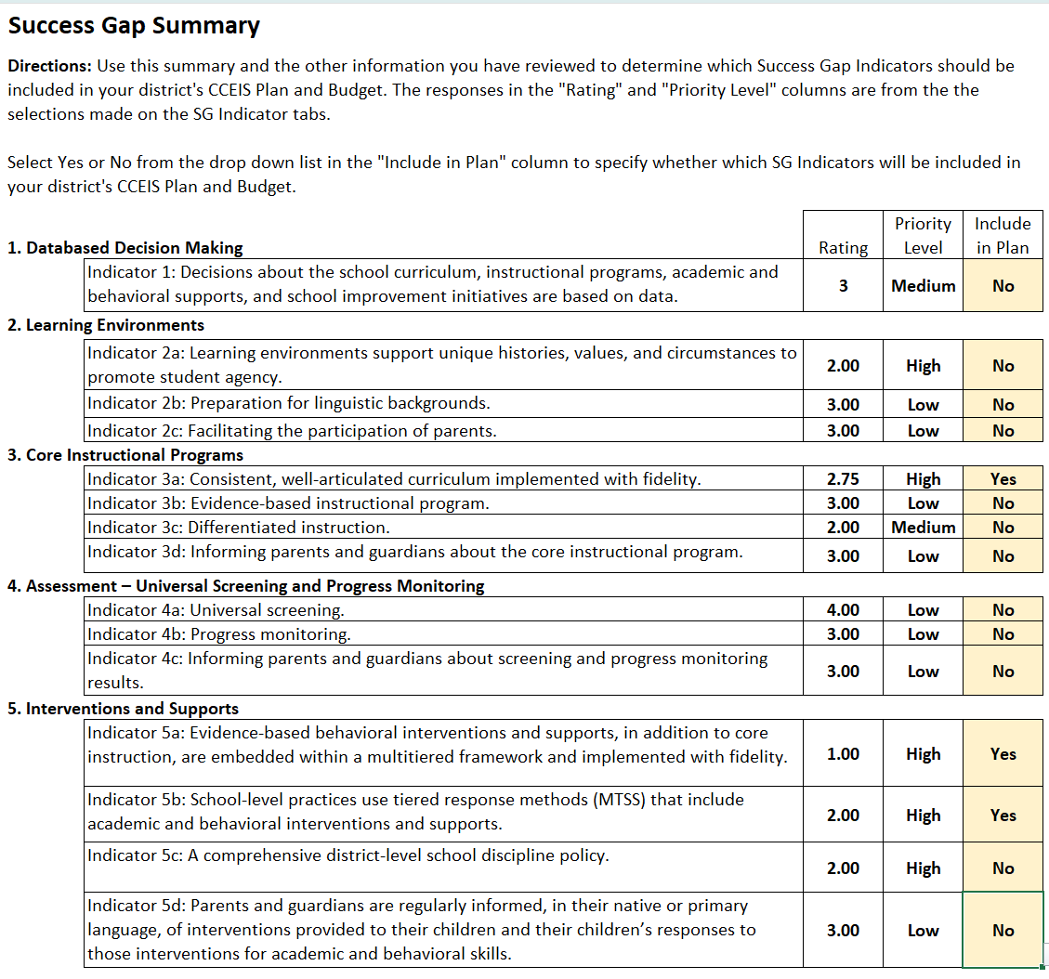
The Root Cause for the tool shown above could be outlined as follows.
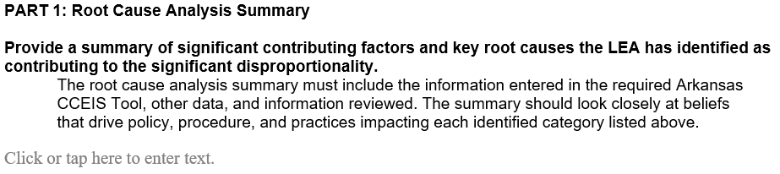
Our root causes from the Success Gap that we are going to work on are:
- 3a Consistent, well articulated curriculum
- 5a Evidence based behavioral interventions
- 5b School wide MTSS including academic and behavioral supports

Each item noted with a “Yes” is listed. The root causes are limited to ensure that the plan can target its focus. The district may include findings from the root cause review of the specific student group data. Again the total for all root causes should be limited to three (success gap + student data = 3 root causes max).
No other information is needed in this section.
PART 2: CCEIS Program Information
Part 2 describes general information about the program.

List the programs or interventions the district is using to address the root causes identified.
Examples include: PBIS, Capturing Kids Hearts, District will do _____ reading program (be sure it is on the DESE approved list.)

(What is the program(s) you are using?)

Programs are not specific staff members. Describe what that staff member will be implementing in the district.
Use the space provided to describe how each of the interventions listed in #1 connects to the identified root causes.

(Why did you choose this program?)

What are the evidence-based components you are using for each intervention listed in #1? List the key components that will address the root causes. Connect how the specific interventions will improve your disproportionality.

(How will you implement the program?)

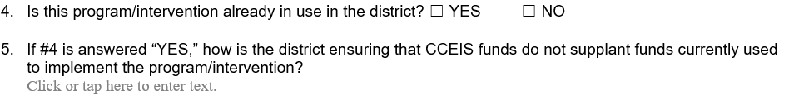

Questions 4 -6 are used to help identify the potential for supplanting. If you answer YES to number 4, be sure you describe what is going to be different or how the proposed interventions are not supplanting.
- Stating the district will be sure it is not supplanting will not be enough of an answer.
- What will be different from what the district is already doing? How is a program being expanded beyond what exists?
- Did you answer yes, because CCEIS was in effect for the same area last year, and you are continuing the plan? If so state this information.

List the grade levels or grade bands the program will be addressing.

(Who is participating?)

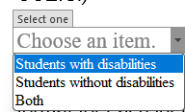

Use the dropdown to select your answer. No other response or explanation is required.

List one or two goals you will use to measure the effectiveness of the program(s) selected. You can also tie the goals back to the area of disproportionality. Remember the purpose of CCEIS is to prevent students from being identified as being in need of special education.

Example:
- If you are identified for disability categories, your goals may include reducing the number of referrals.

- If you are identified for discipline, you may have a goal to reduce the number of office disciplinary referrals or suspensions.

Part 3: Program Description
Use this section to describe the logistics of the program(s).

State how often and for how long the intervention with students will be.
If you are primarily implementing Professional Learning opportunities, outline here how often the sessions (formal, small group, district wide, informal, coaching, etc) will occur.

(When is the program occurring?)

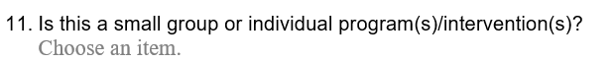
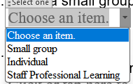
Select the intervention type.

List the number of students who will be tracked as CCEIS participants in eSchool. (A larger number may be participating in the intervention than is tracked in eSchool, and that is ok.)

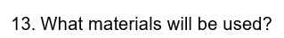
List the specific materials the program requires that the district will purchase to go with the program. The materials listed here will align with the materials included on the budget page. Items included here need to align with and support the interventions outlined in questions 1-3. You do not need to repeat the specific materials in the budget section of the application, since they are named here.

List the tools used to track data and when the district will be reviewing data.

When the data noted in number 14 is reviewed, what changes will be made for students who are progressing faster than expected? Slower than expected?

List the type of staff who will be implementing the program. When classified staff are implementing, describe what they will be doing to implement the program.

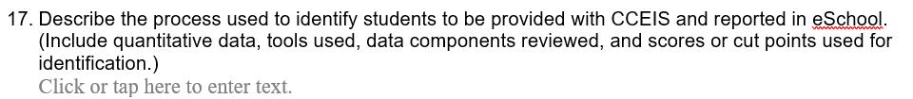

What are the specific data tools and cut points that will be used to identify students for participation and tracking in eSchool? Go granular and very specific. Examples include:
- Students in ___ teachers’ classrooms
- Students who have more than ___ suspensions
- Students who take ____ screener and score ___

Answers that include multiple test names and/or say a committee will decide are not specific enough and will be returned.

The answer should align with the information in question 17. What are the specific data tools and cut points that will be used to stop student participation and tracking in eSchool? Examples include:
- Students leave ___ teachers’ classrooms (the school year ends)
- Students who have no suspensions during the year
- Students who take ____ screener and score ___

Answers that include multiple test names and/or say a committee will decide are not specific enough and will be returned.

Part 4: Data Management (applies for the duration of the funds)
Use this section to outline Data management. CCEIS must be tracked in eSchool until the funds are completely used, including updated allocations and carry-over.

List the people who will enter the data. This is often noted as the data clerk or the special education director.

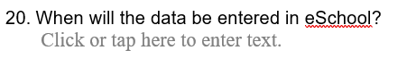
List how often CCEIS data will be entered.

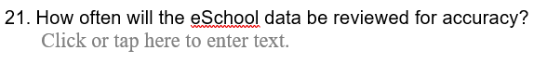
State how often the CCEIS data will be reviewed to ensure it is correct.

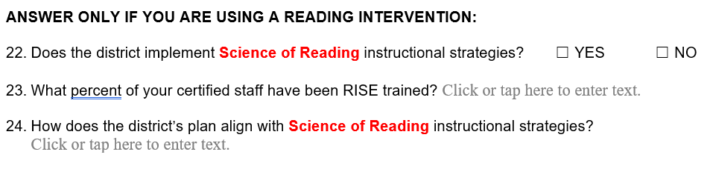
22-24 are only required if the district has reading interventions in its plan. If you are addressing reading, #24 needs to outline how this program will align with the SoR.

Part 5: Program Evaluation
This section describes how the district will determine the effectiveness of the program.

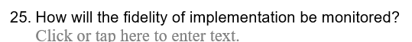
Describe the fidelity checks that will be in place.

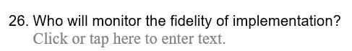
Name the people or roles who will be checking fidelity.

List what you will review to ensure the goals listed in #9 are met.

SKIP if this is your first year for CCEIS for this area of significant disproportionality.

List the data reviewed to determine if the goals were met and how effective the program was last year.

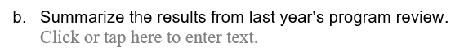
Summarize the findings from the data review.
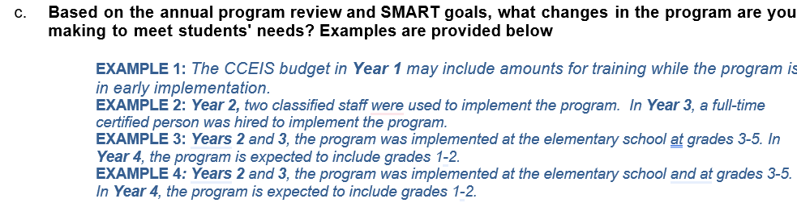

Outline the changes in the plan the district is making based on the findings from the program review.

Part 6: Finance CCEIS Budget

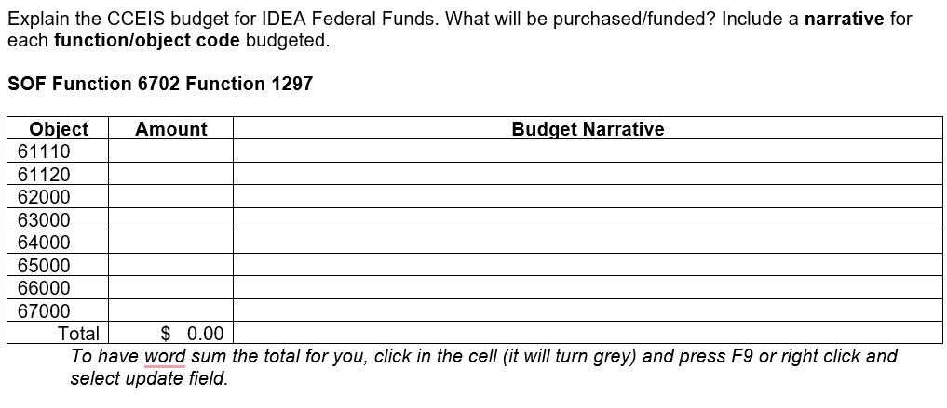

The items included in the budget must align with the information in the application, specifically questions 1, 13, and 16. If a program or material is listed in the budget and not in the application, we will return the application for clarification.

Use the preliminary CCEIS allocation chart in the school year in which you are completing the application to determine the required application budget amount. This amount will differ from what the LEA actually budgets in eSchool for CCEIS.

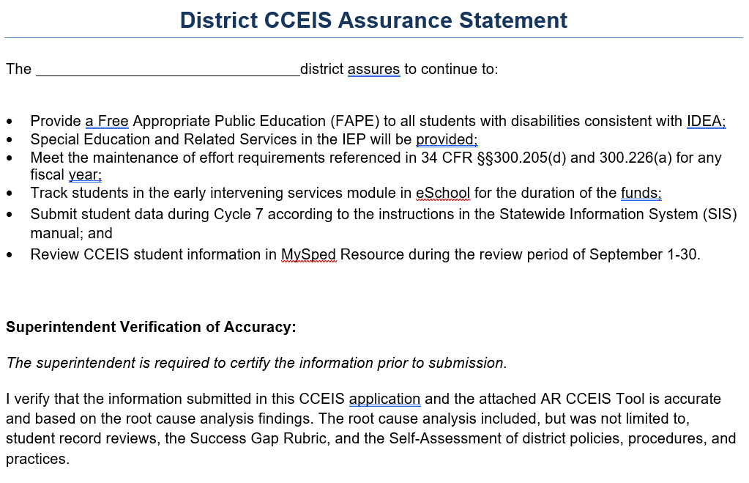
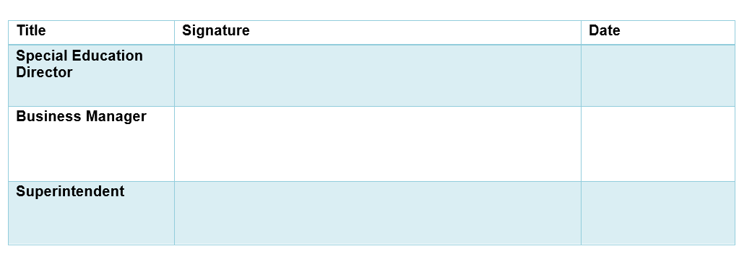

Once the application is complete, review and sign the assurances before submitting. Remember that applications are due by March 31. Email them to sped.finance@ade.arkansas.gov.

